CPE301 – SPRING 2019

Midterm2

Student Name: Kyungseo Yun

Student #: 2001091216

Student Email: yunk93@unlv.nevada.edu

Primary Github address: <https://github.com/biscuit0x/submission_yun.git>

Directory: submission_yun/DesignAssignments/midterm2/

Submit the following for all Labs:

1. In the document, for each task submit the modified or included code (only) with highlights and justifications of the modifications. Also, include the comments.
2. Use the previously create a Github repository with a random name (no CPE/301, Lastname, Firstname). Place all labs under the root folder ESD301/DA, sub-folder named LABXX, with one document and one video link file for each lab, place modified asm/c files named as LabXX-TYY.asm/c.
3. If multiple asm/c files or other libraries are used, create a folder LabXX-TYY and place these files inside the folder.
4. The folder should have a) Word document (see template), b) source code file(s) and other include files, c) text file with youtube video links (see template).

1. Components :

atmega328

jumper wires

esp8366

APDS-9960

2. C code

/*

* midterm2.c

*

* Created: 12/14/2019 1:48:41 PM

* Author : jayne

*/

#define F_CPU 16000000UL

#define BAUD_PRESCALAR (((F_CPU / (BAUDRATE * 16UL))) - 1)

#define I2C_WRITE 0x00

#define I2C_READ 0x01

#define APDS9960_WRITE_ADR (APDS9960_I2C_ADDR << 1) | I2C_WRITE

#define APDS9960_READ_ADR (APDS9960_I2C_ADDR << 1) | I2C_READ

#include <avr/io.h>

#include <util/delay.h>

#include <stdio.h>

#include <stdlib.h>

#include <stdint.h>

#include "i2c_master.h"

#include "uart.c"

#include "APDS9960_def.h"

#include "adps.c"

char colors[256];

uint16_t ambient, red, green, blue = 0;

void read_adc(void);

int main(void)

{

i2c_init(); // initialize i2c

USART_Init(); // initialize uart

apds_init(); //initialize APDS960

//connects to wifi

USART_SendString("AT\r\n");

_delay_ms(1000);

USART_SendString("AT+CWMODE=1\r\n");

_delay_ms(1000);

USART_SendString("AT+CWLAP\r\n");

_delay_ms(4000);

USART_SendString("AT+CWJAP=\"LAST\",\"OVER\"\r\n");

_delay_ms(3000);

while (1) //loop

{

read_adc(); //read colors

USART_SendString("AT+CIPSTART=\"TCP\",\"api.thingspeak.com\",80\r\n"); //thingspeak connection

_delay_ms(3000);

USART_SendString("AT+CIPSEND=200\r\n"); //send 200 characters

_delay_ms(1000);

snprintf(colors, sizeof(colors),"GET https://api.thingspeak.com/update?api_key=NX0KTDW6RHKFUTFC&field1=%d&field2=%d&field3=%d&field4=%d\r\n", ambient, red, green, blue);

USART_SendString(colors); //send temperature

_delay_ms(1000);

USART_SendString("AT+CIPCLOSE\r\n"); //end

_delay_ms(1000);

}

}

void read_adc(void) { //read sensor values

i2c_start(APDS9960_WRITE_ADR);

i2c_write(APDS9960_CDATAL);

i2c_stop();

i2c_start(APDS9960_READ_ADR);

ambient =((int)i2c_read_ack()|((int)i2c_read_ack()<<8));

red = ((int)i2c_read_ack()|((int)i2c_read_ack()<<8));

green = ((int)i2c_read_ack()|((int)i2c_read_ack()<<8));

blue = ((int)i2c_read_ack()|((int)i2c_read_ack()<<8));

i2c_stop();

}

3. Schematic

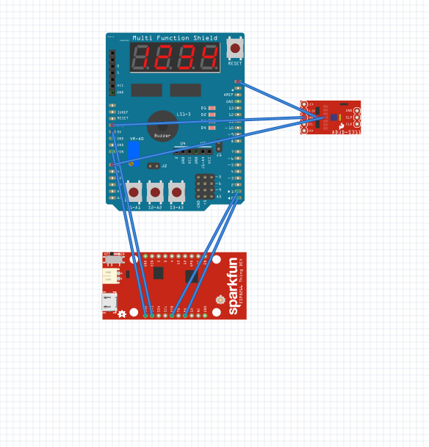

4. Screenshot

Atmel studio :

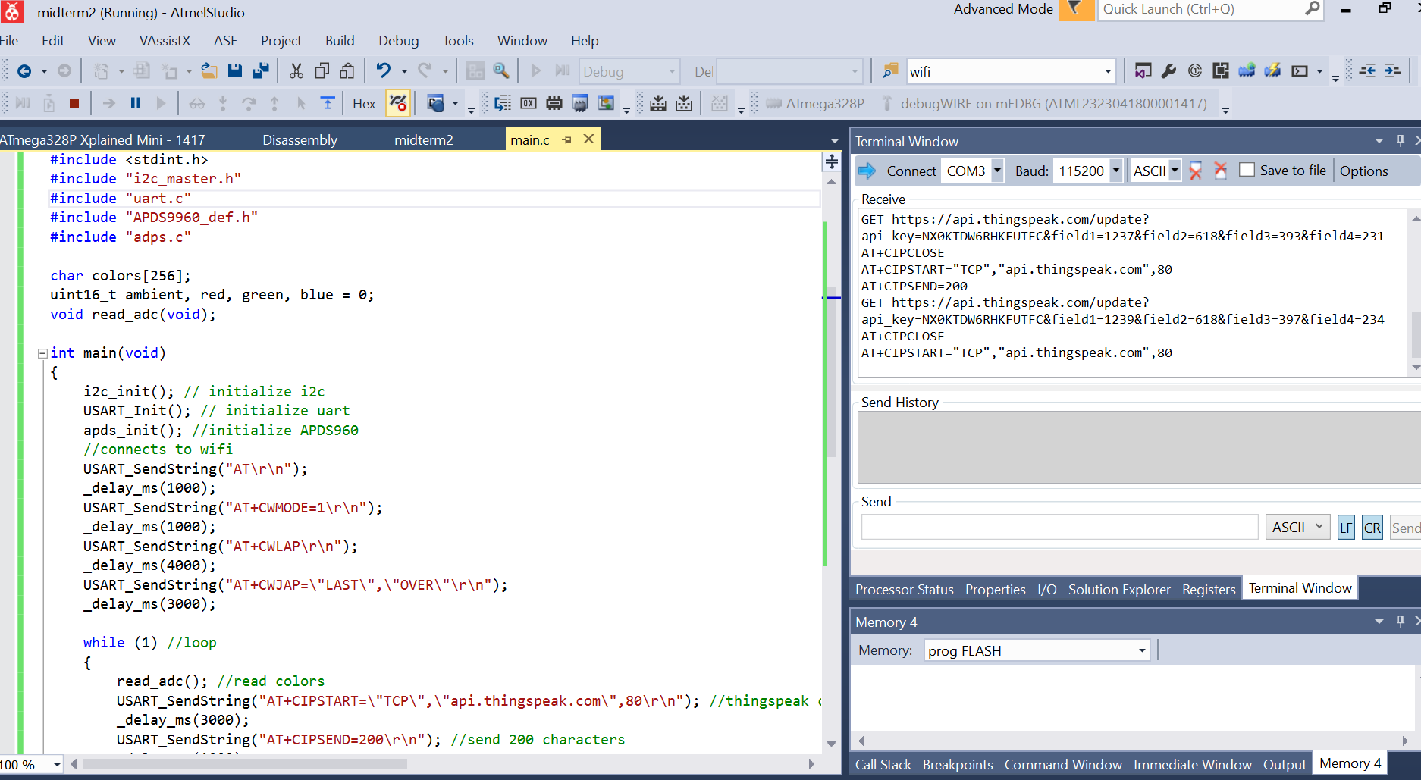

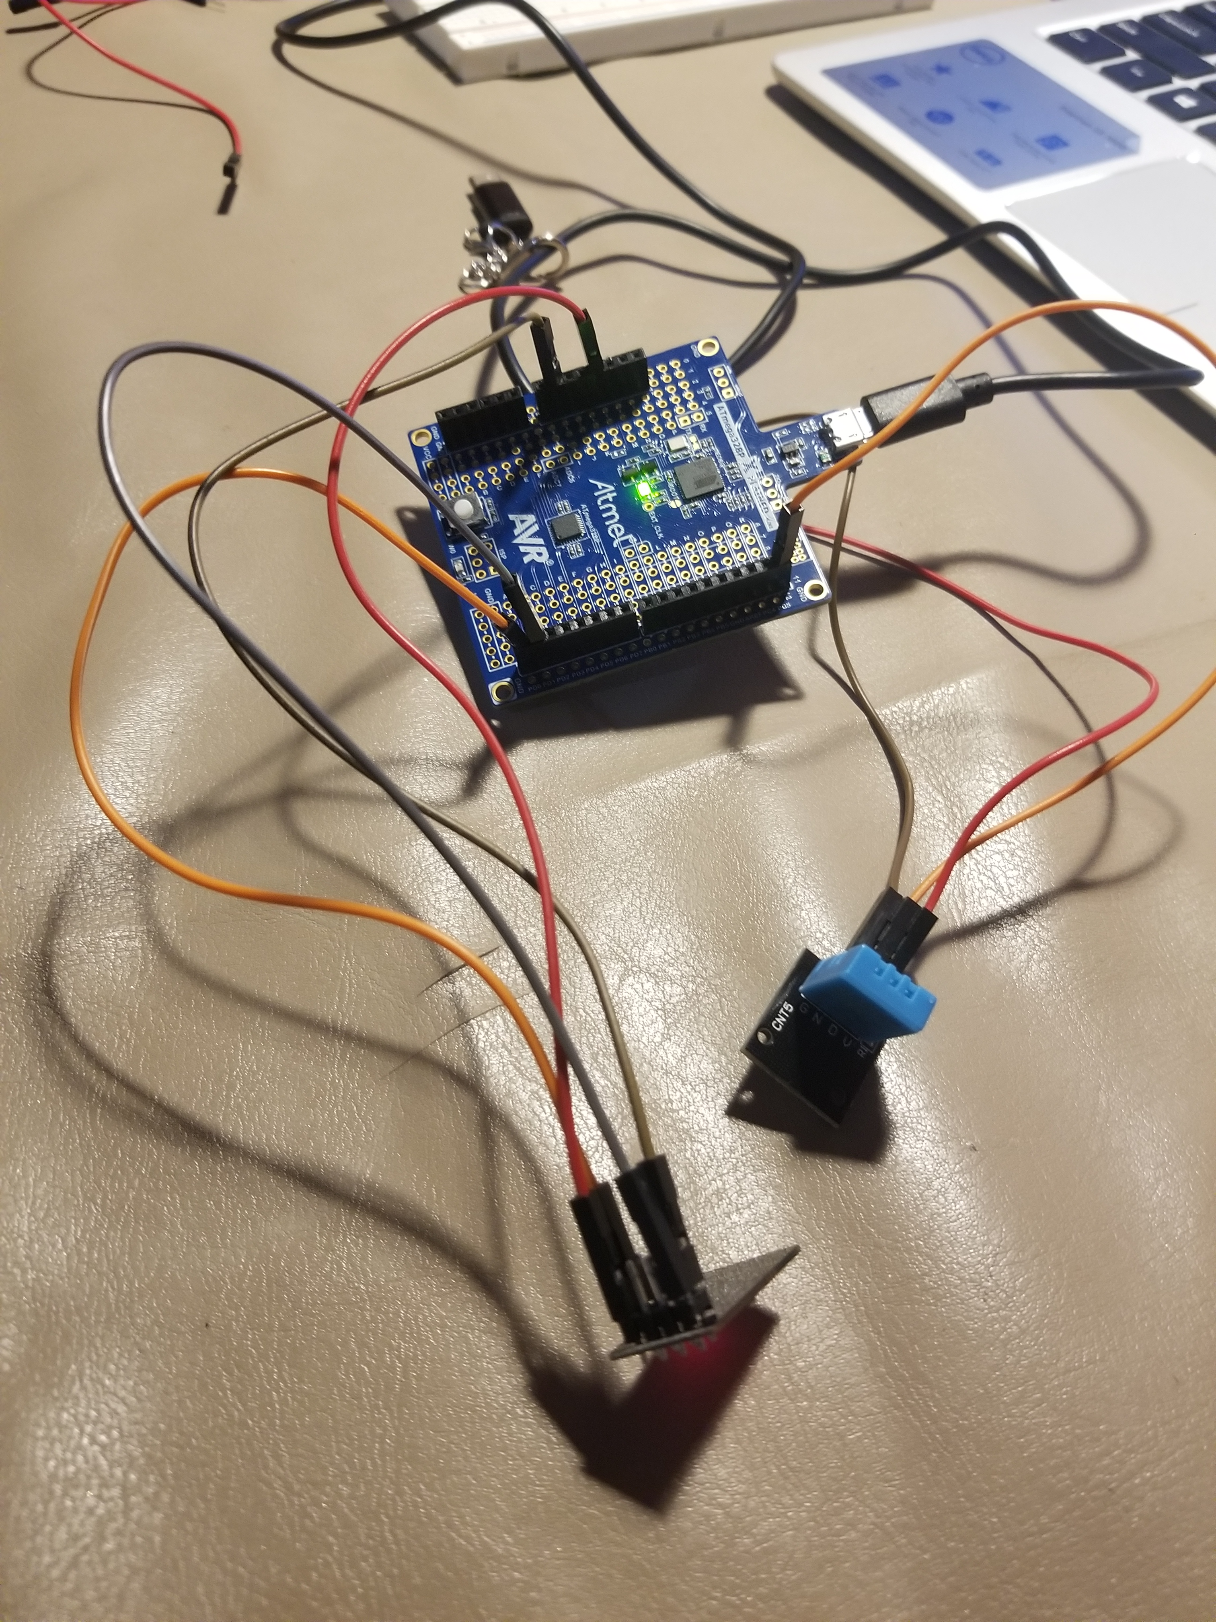5. Photo / video

https://youtu.be/az4UatoSAaE